**DJango**

**What is web application?**

A web application is collection resources/programs/services which are accessed using internet or web.

**What is need of web application?**

1. Sharing resources or providing services to clients world wide
2. Providing 24/7 services
3. Services at door step by just clicking a button

**Types of web applications**

1. Static web applications
2. Dynamic web applications
   1. Multipage web application
   2. Single Page web application
   3. Progressive web application

**Static web application**

A static web application is collection static web resources or resources. A static web application is collection of,

1. HTML
2. CSS
3. Bootstrap
4. Images
5. Audio
6. Video

In static web application, web server serve requested resources to the client. In static web application the resources are not executed within server but it is downloaded from server and executed within client browser.

In static web application the content does not changes from one request to another.

**Example: tutorials, blogs, CMS**

**Dynamic web application**

A dynamic web application is collection of static resources and dynamic resources. These are service based applications, which provide services to clients.

Eg: banking application, e-shopping, e-reservation,….

Web pages are two types

1. Static web page
2. Dynamic web page

Web pages are created using HTML,CSS,Bootstrap,javascript

Static web page is a web page whose content is predefined, this static web pages are created using HTML. These web pages are created and saved within server with extension .html

Dynamic web page is a web page, whose content changes from one request/input to another. These dynamic web pages are generated or created using server side web technologies (PHP, ASP,Servlets,JSP,DJango).

Dynamic web applications are interactive web applications. These web applications works based on two things,

1. Request/input
2. Response/output

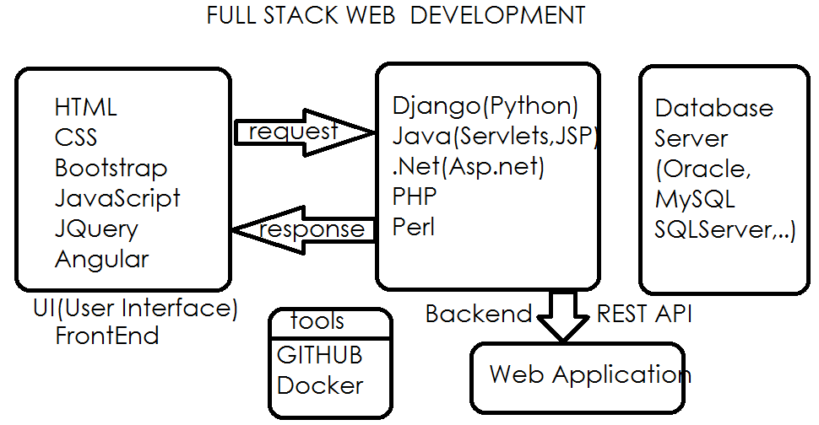

In web application development we required two programs.

1. Client (browser)
2. Server (Web Server/HTTP Server, Application Server)